## ASSIGNMENT-05

## Create a public bucket in AWS.Upload a file and give the necessary permission to check the file URL is working or not.

## Part 1:Create a Public Bucket

## 1.Sign in to AWS:

## .Login to AWS Management Console.

## .Navigate to Amazon S3 console.

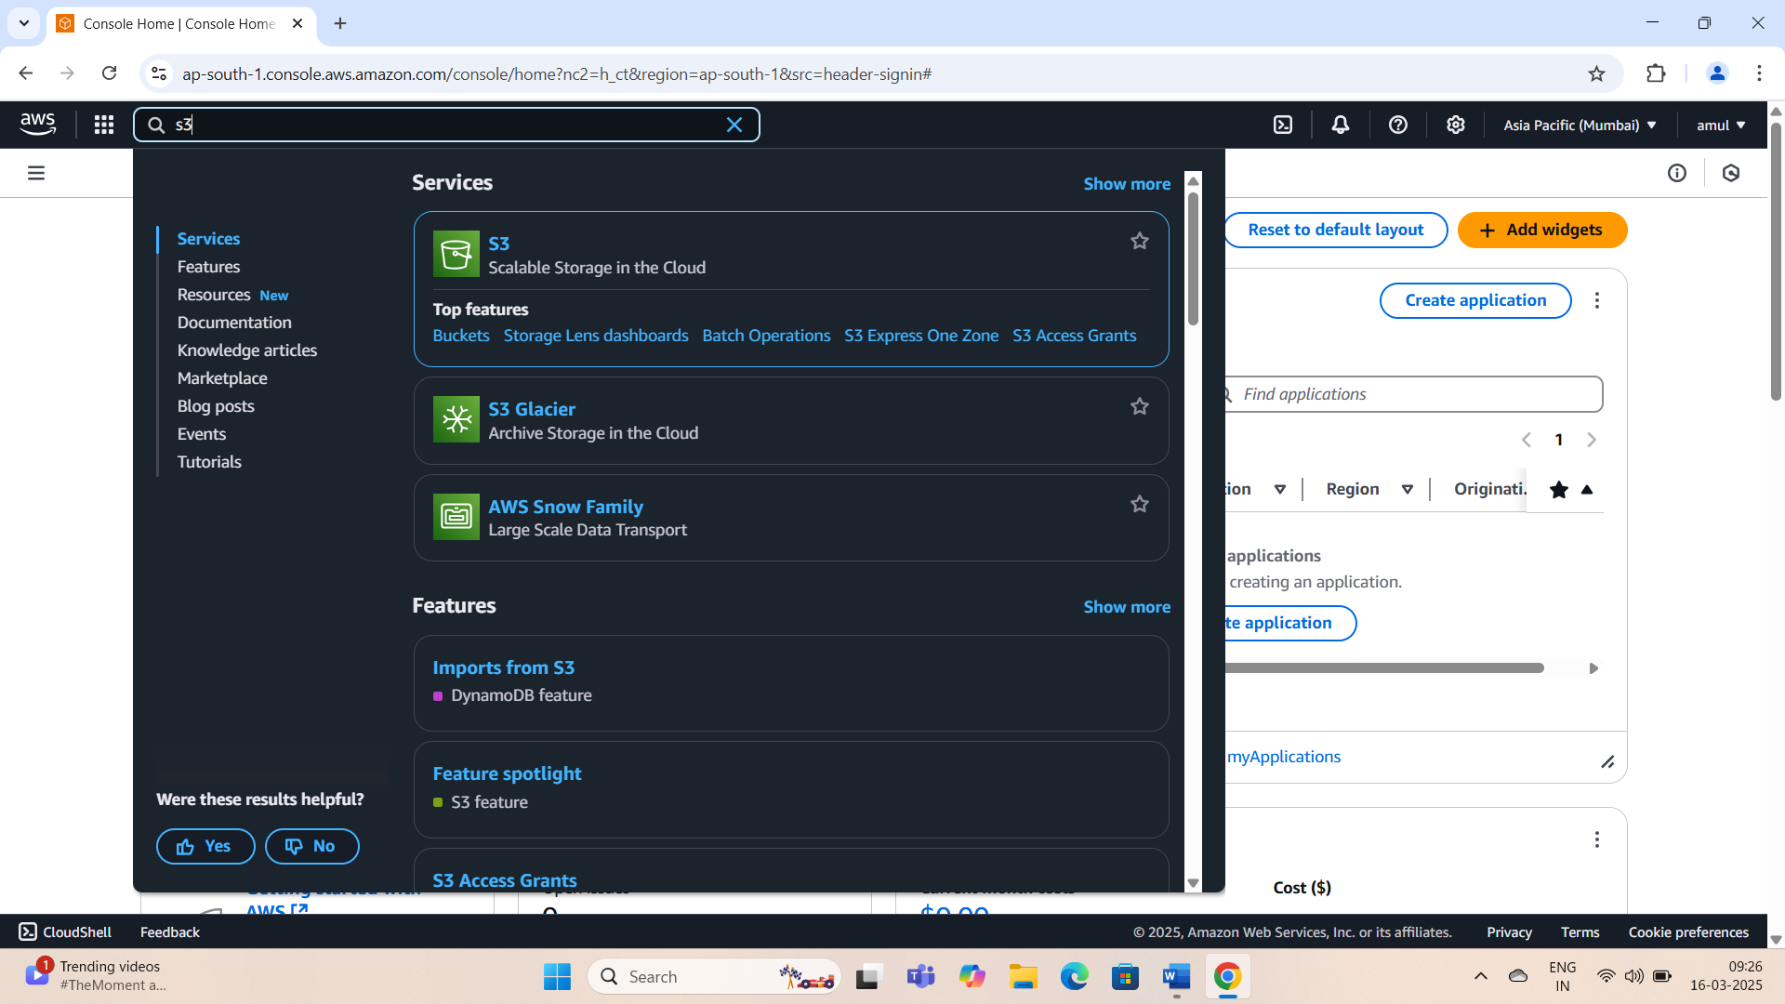

## 2. Navigate to buckets:

## .From the left-hand menu,select Buckets.

## 3.Create a bucket:

## .Click create bucket.

## .On the Create Bucket page:

## .Bucket Name:Enter a unique name for your bucket(e.g.,aneeshpublicbucket).

## .Region:Select your preferred AWS region.

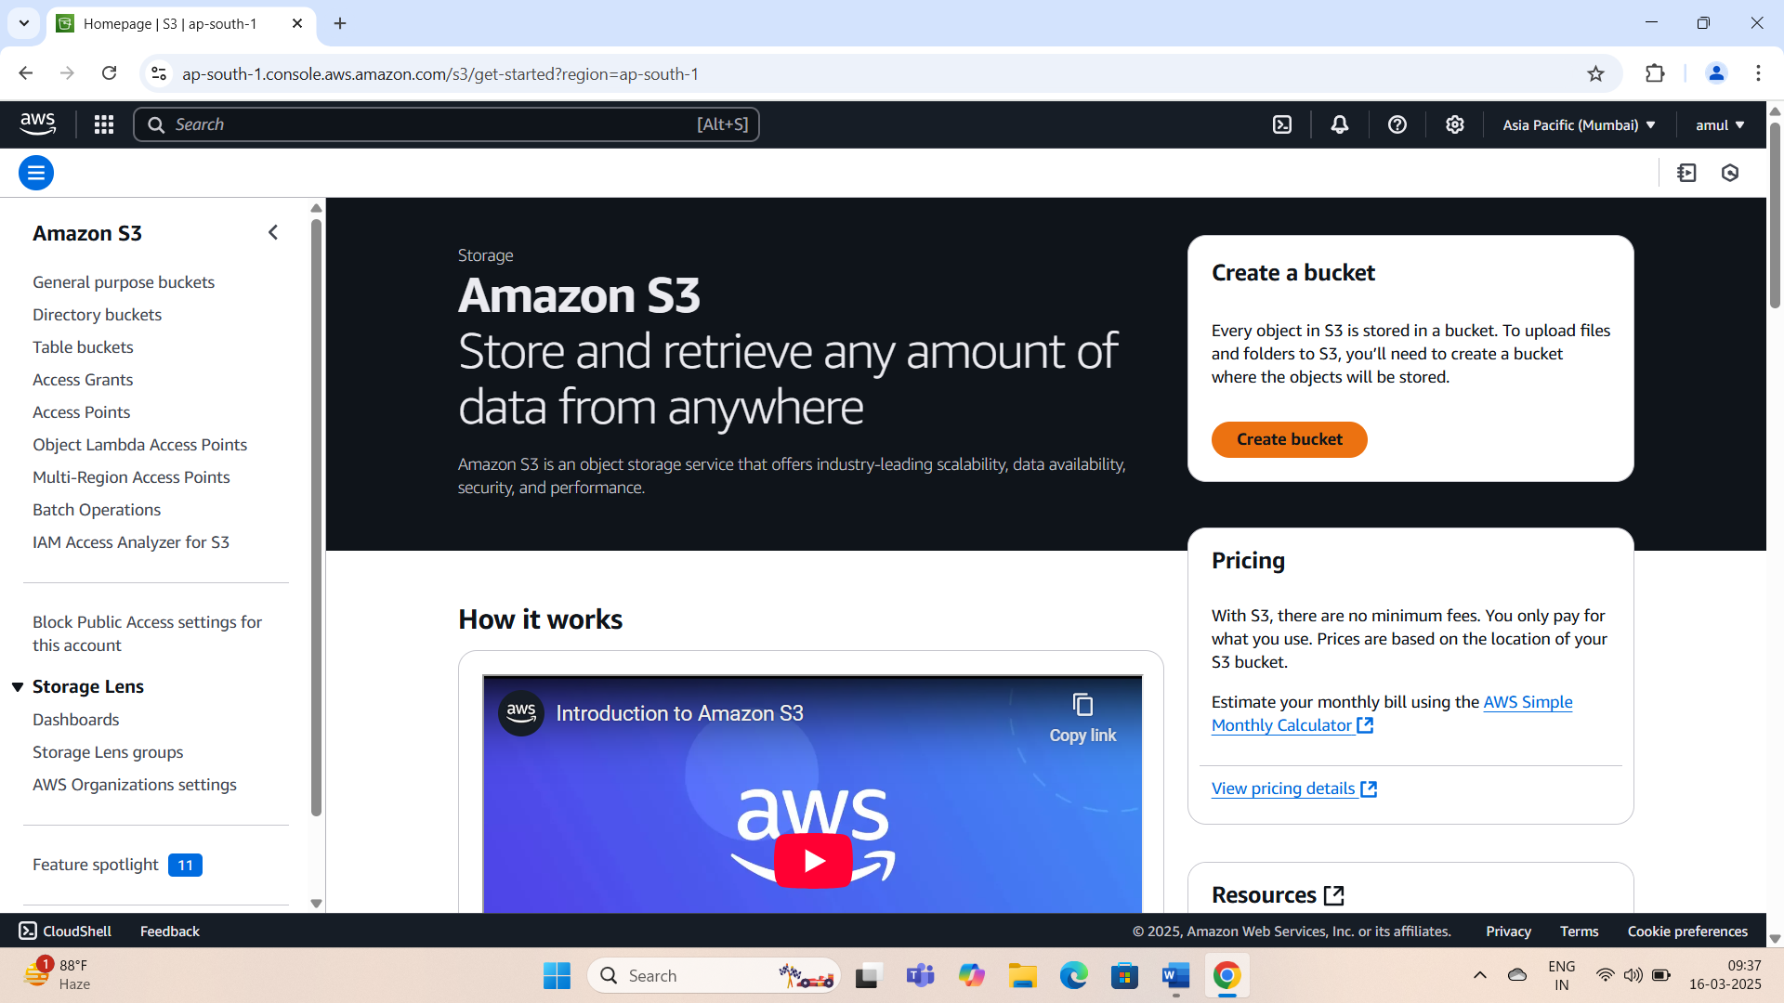

## 4.Set Object Ownership:

## .Under Object Ownership,enable ACLs to control ownership of uploaded objects.

## .Choose Bucket owner enforced,ACLs enabled.

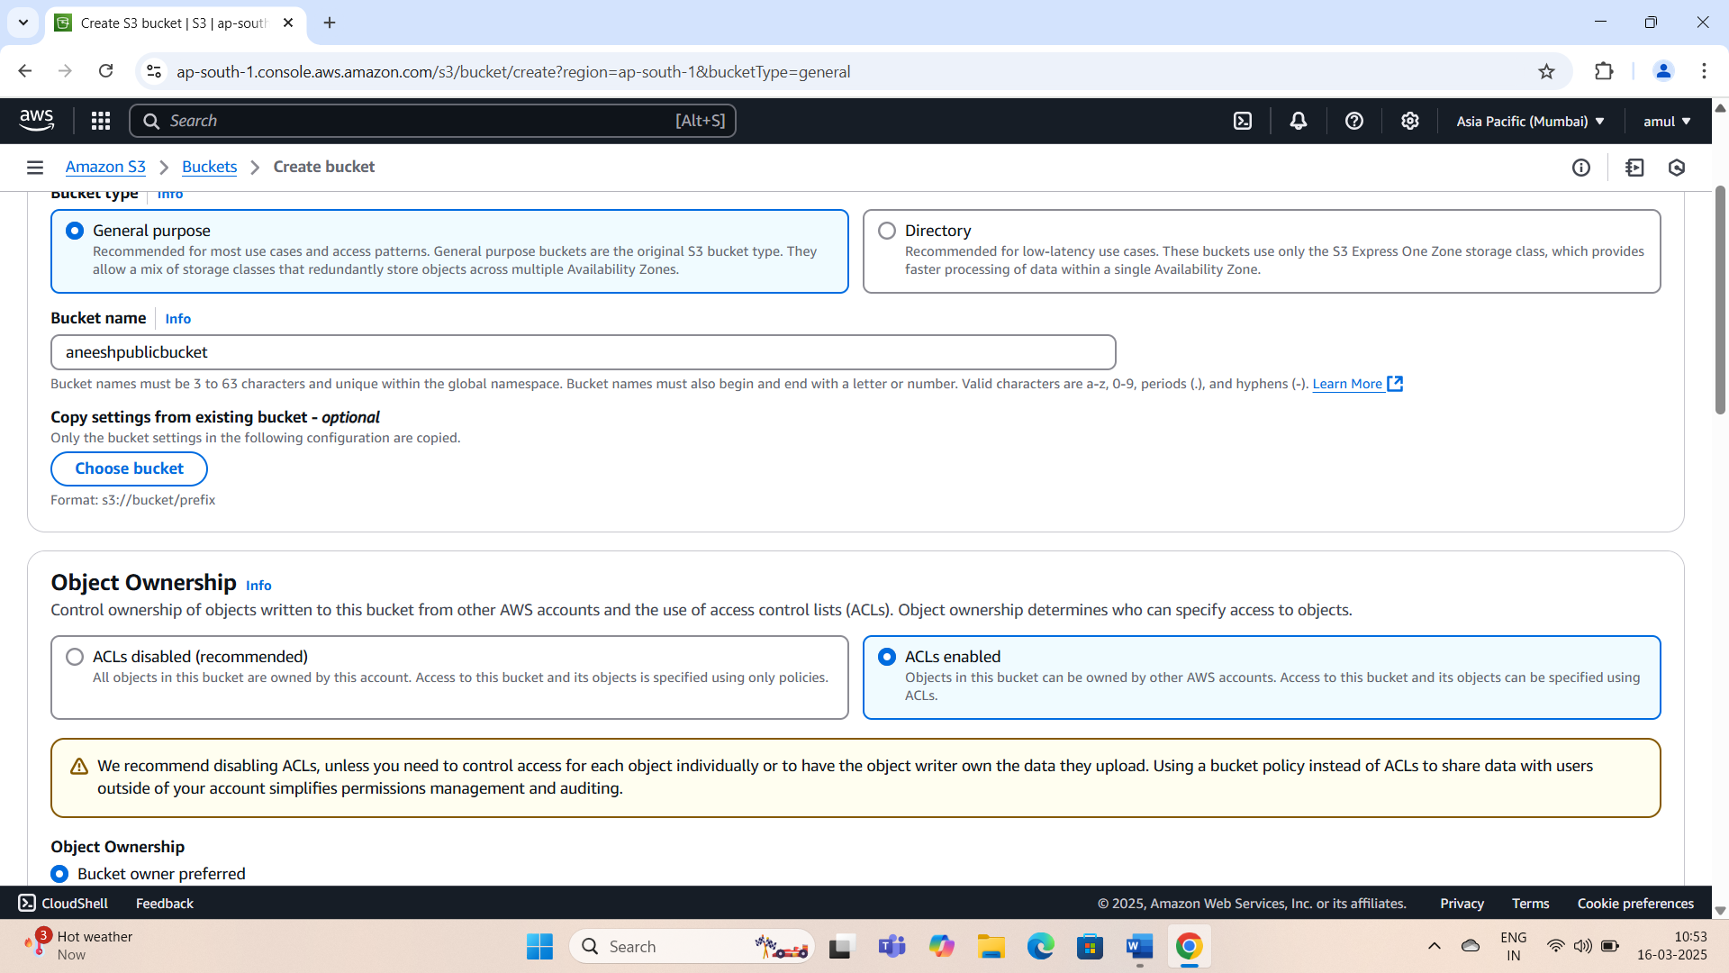

## 5.Adjust Public Access Settings:

## .Uncheck the Block Public Access settings for this bucket checkbox.

## .Tick the acknowledgment box confirming your choice.

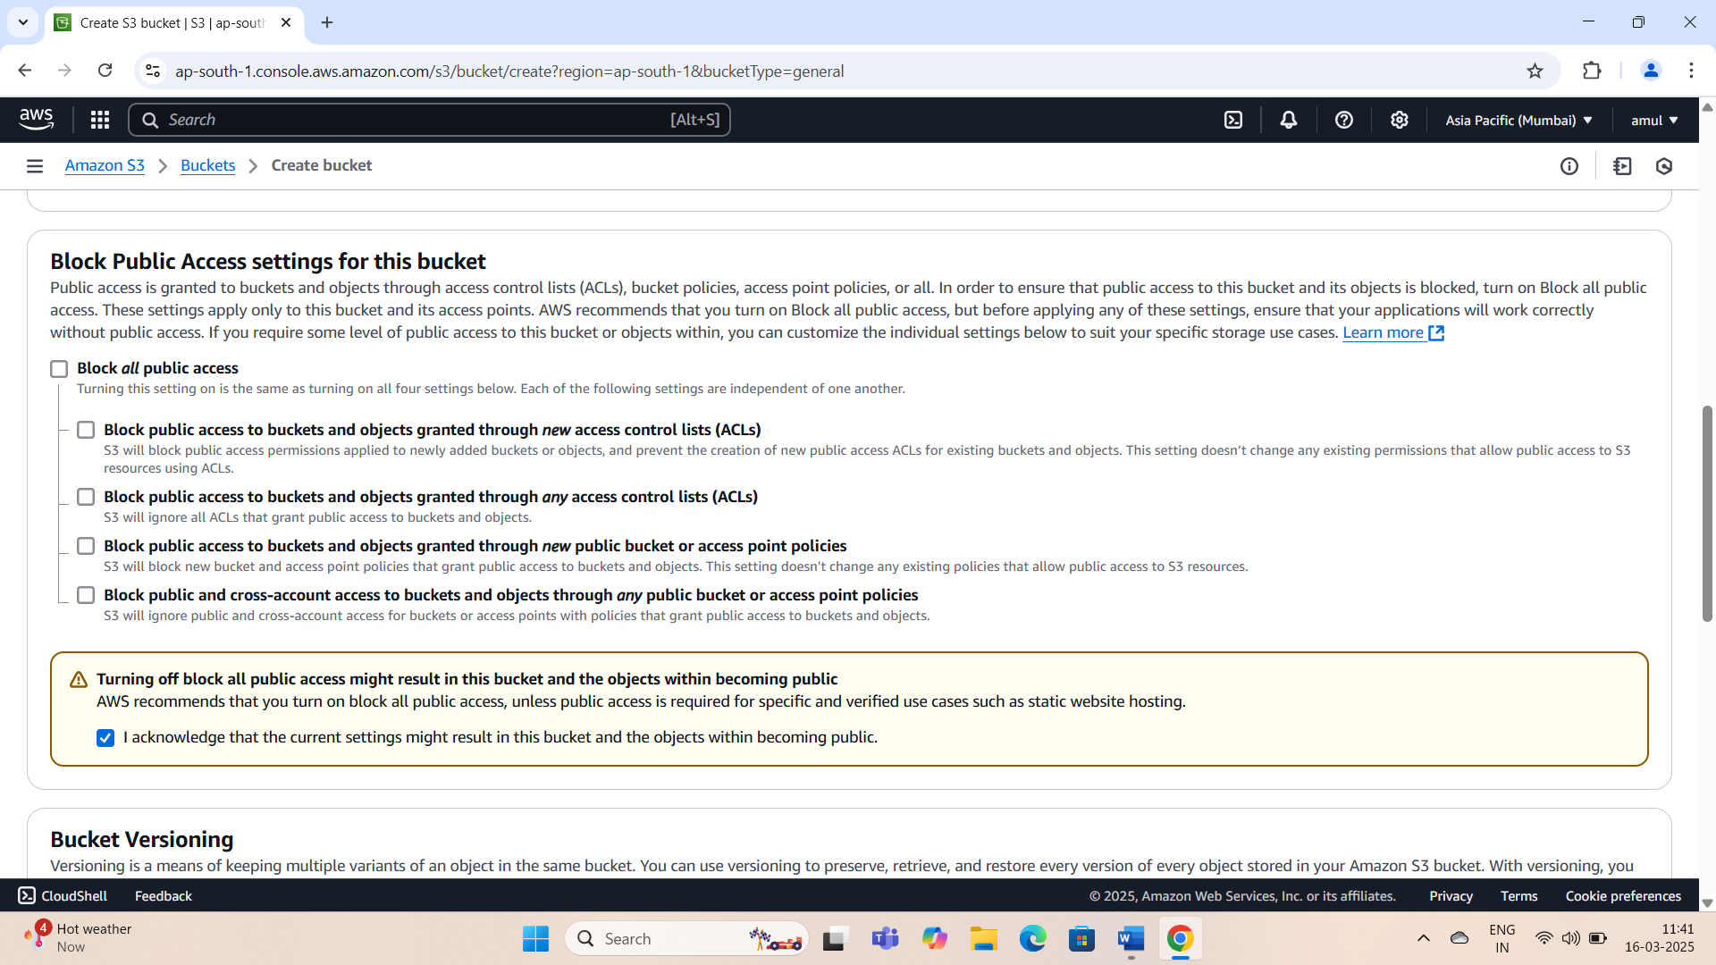

## 6.Create the bucket:

## .Click Create Bucket to finalize the process.

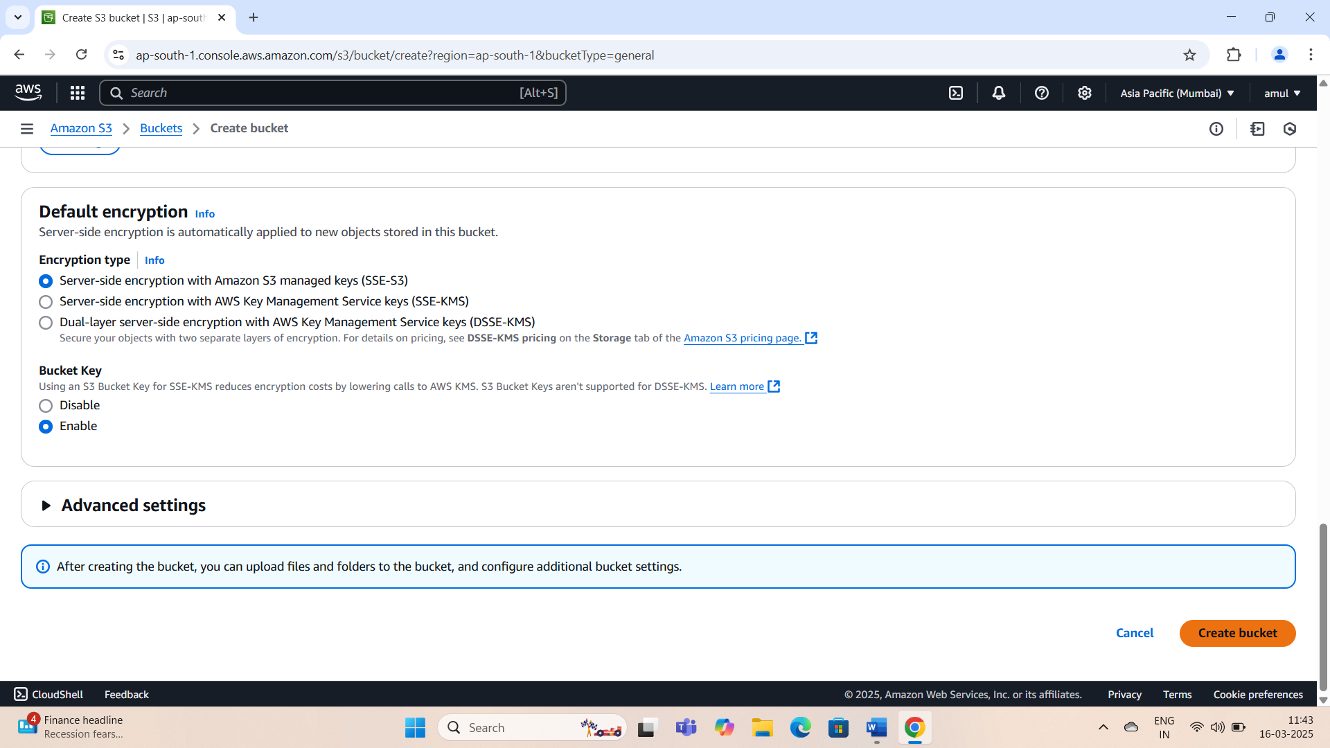

## Part 2:Upload Files and Grant Public Access

## 1.Open the Bucket:

## .After creation,locate your bucket in the list and click its name.

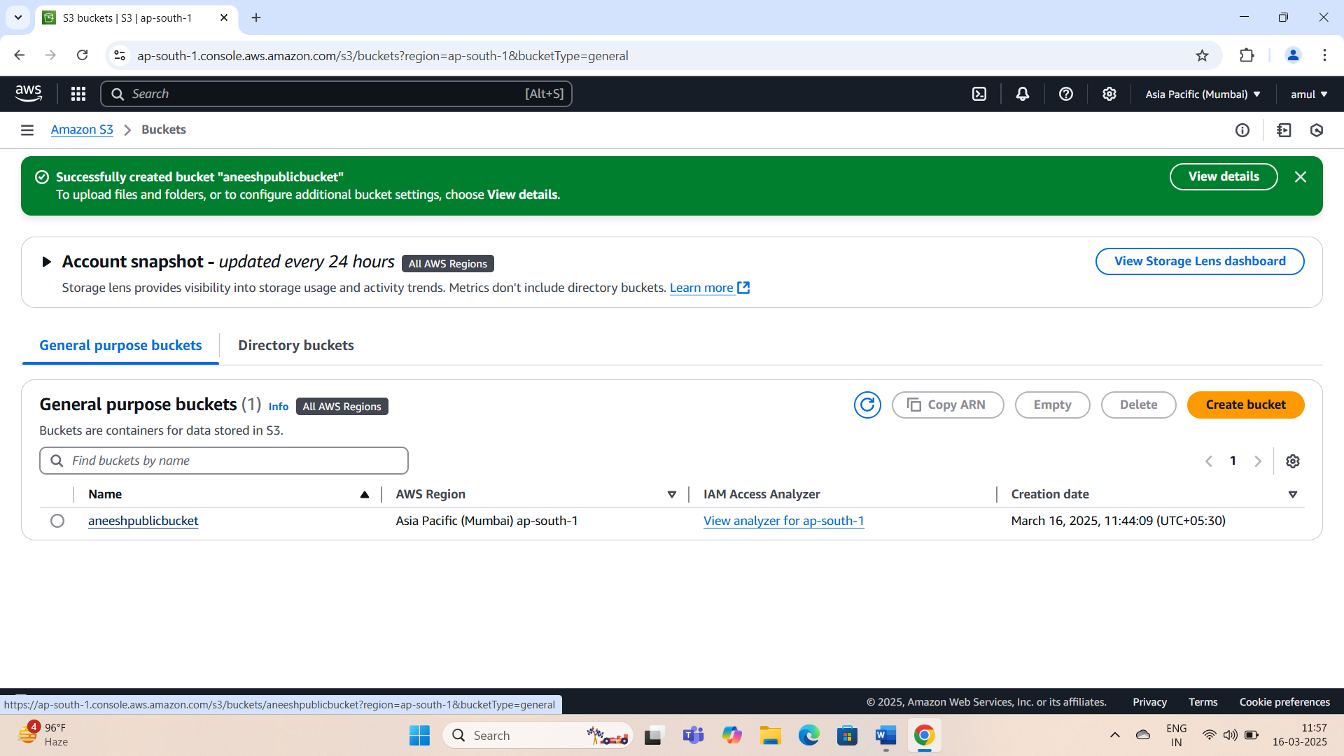

## 2.Upload Files:

## .Within the bucket,click Upload.

## .On the upload page,click Add files and select the file to Upload.

## .Click Upload to complete the process.

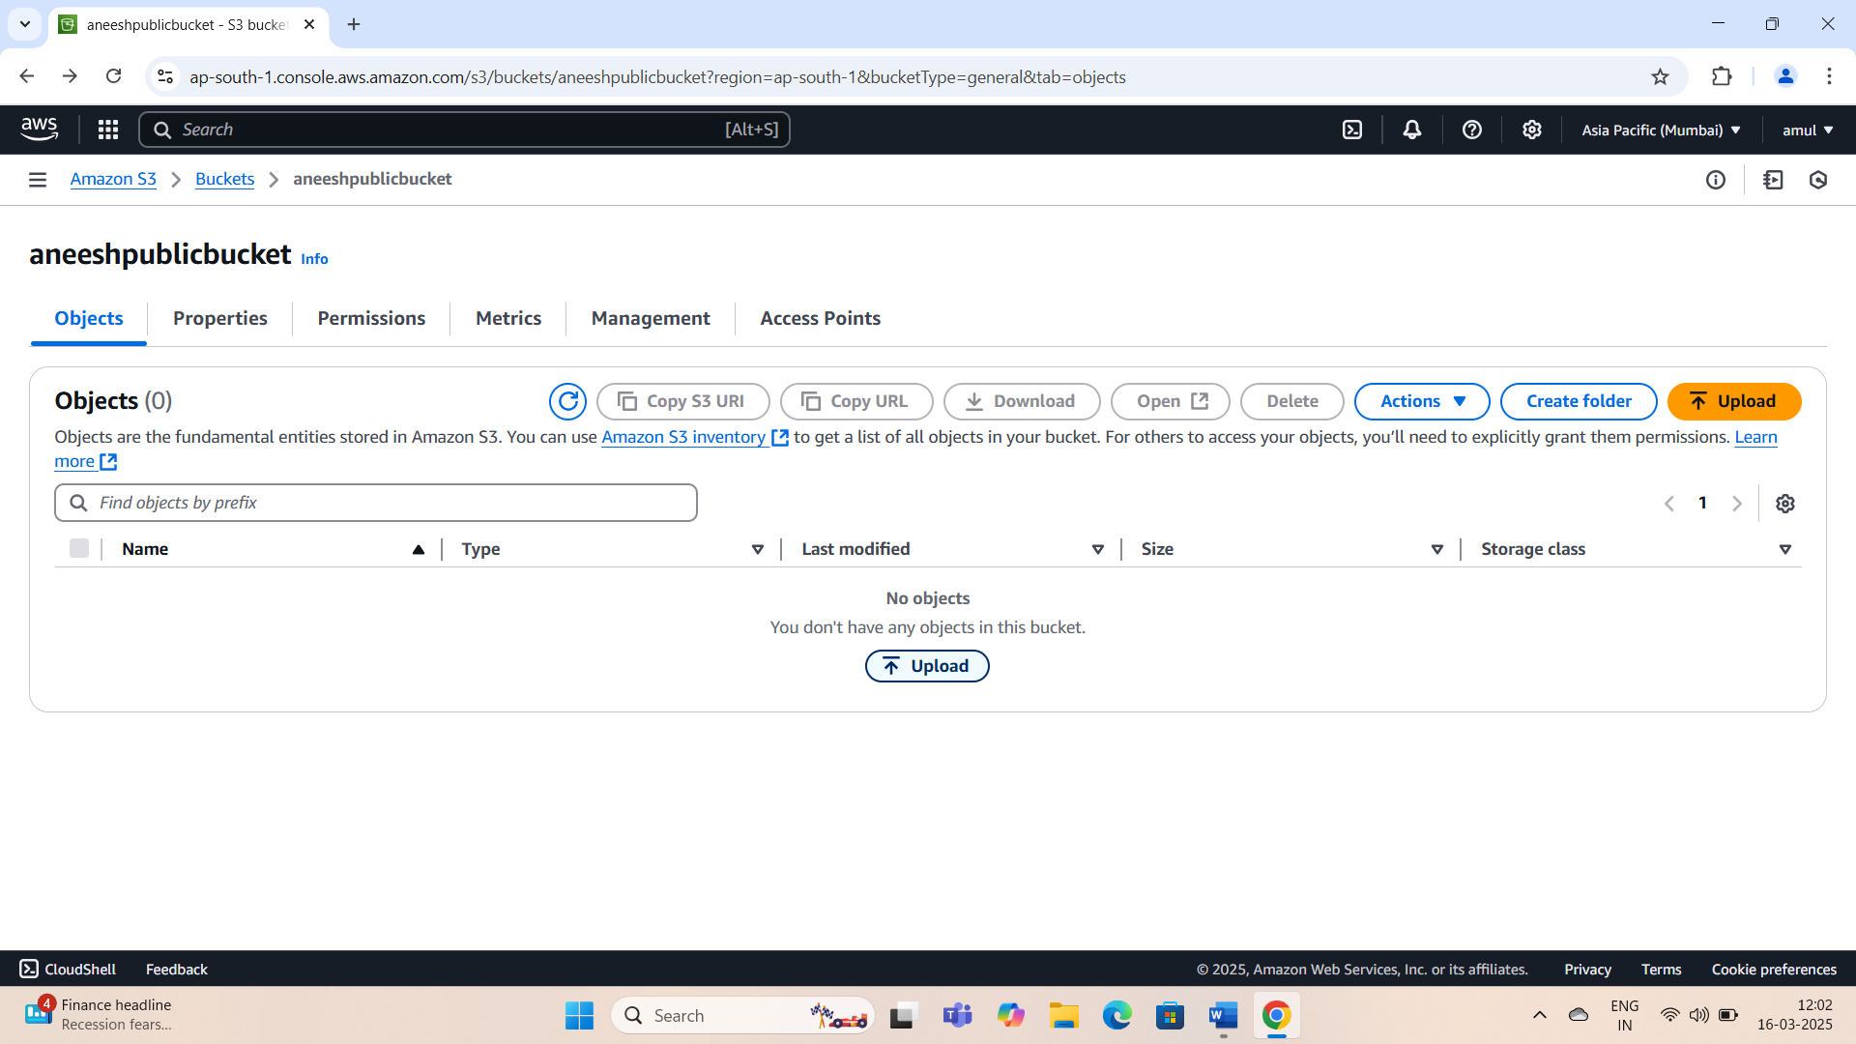

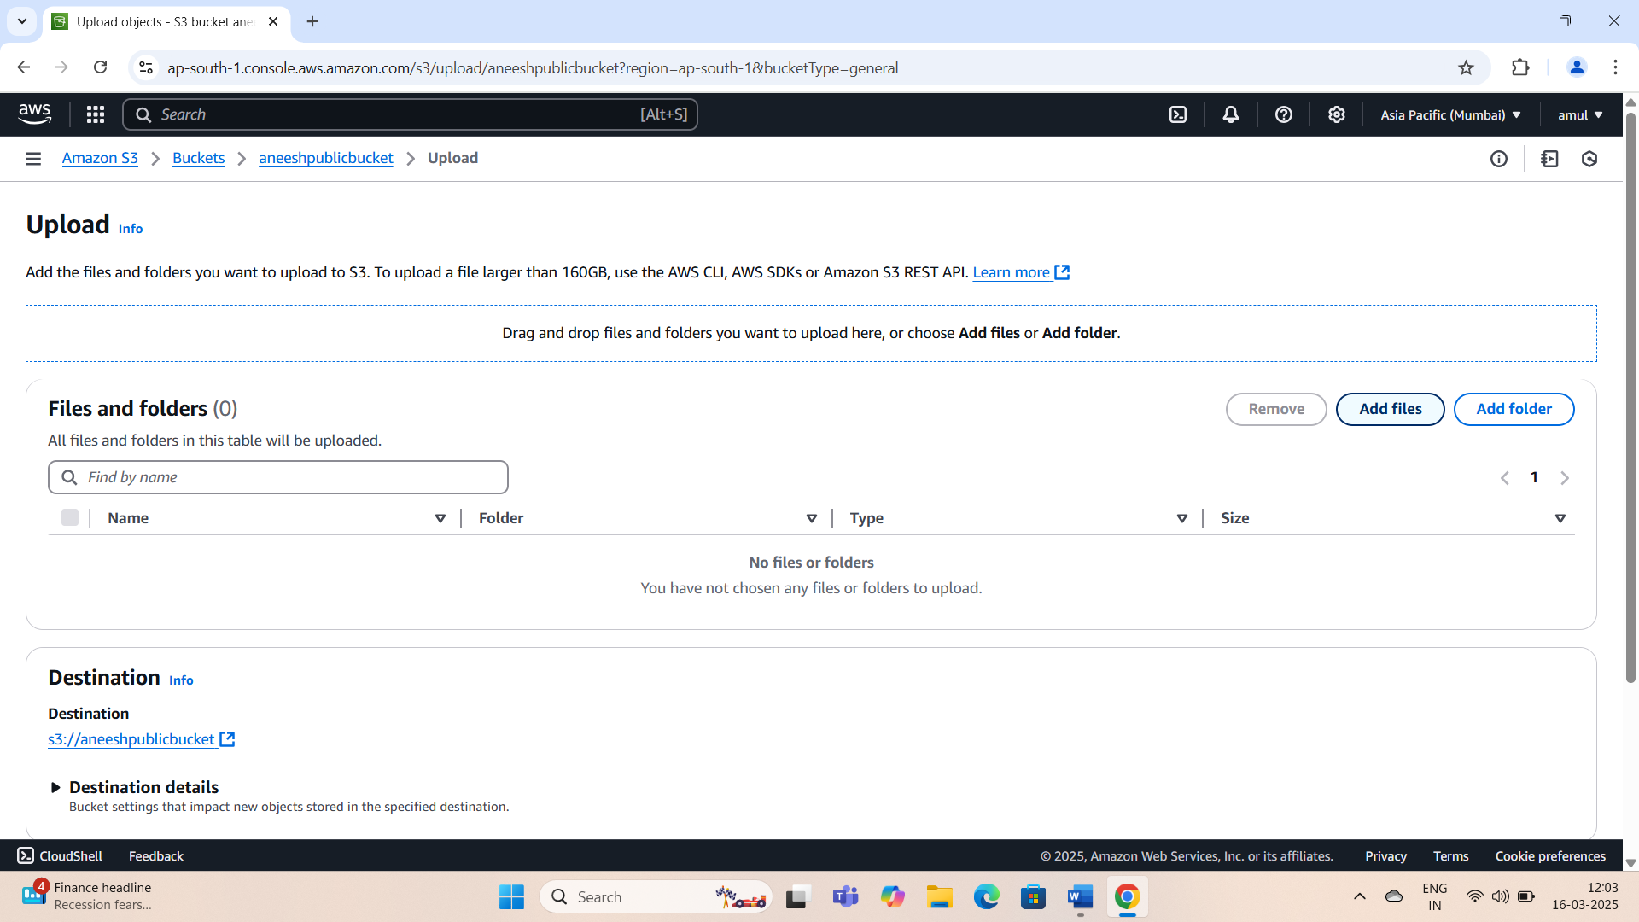

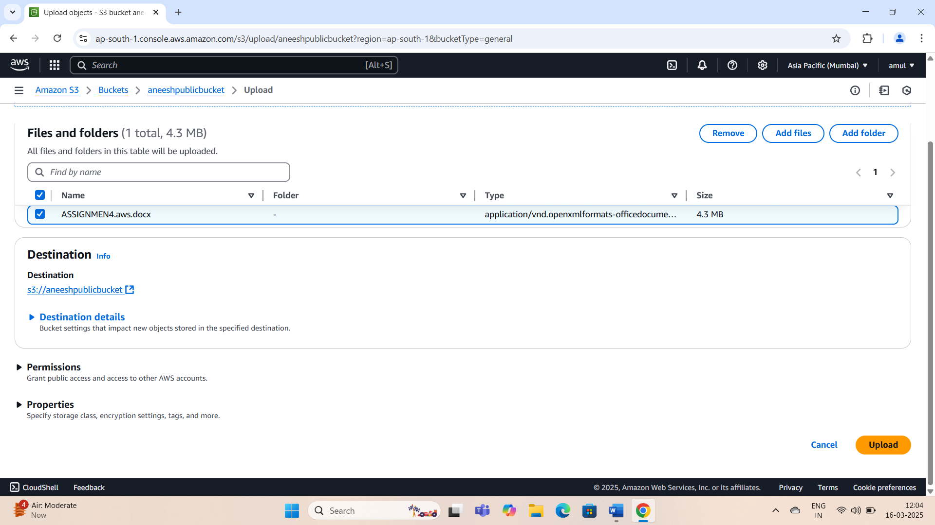

## 3.Set Permissions for Uploaded Files:

## .Select the uploaded file and navigate to the Permissions tab.

## .Under Access Control List(ACL) ,click Edit.

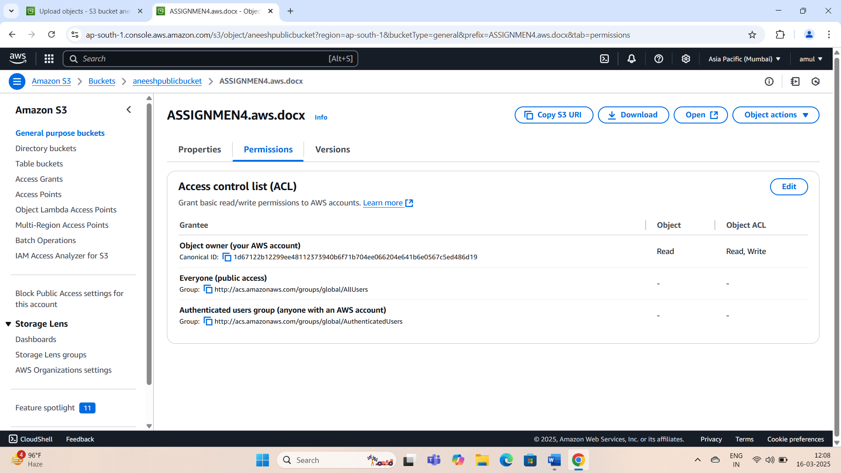

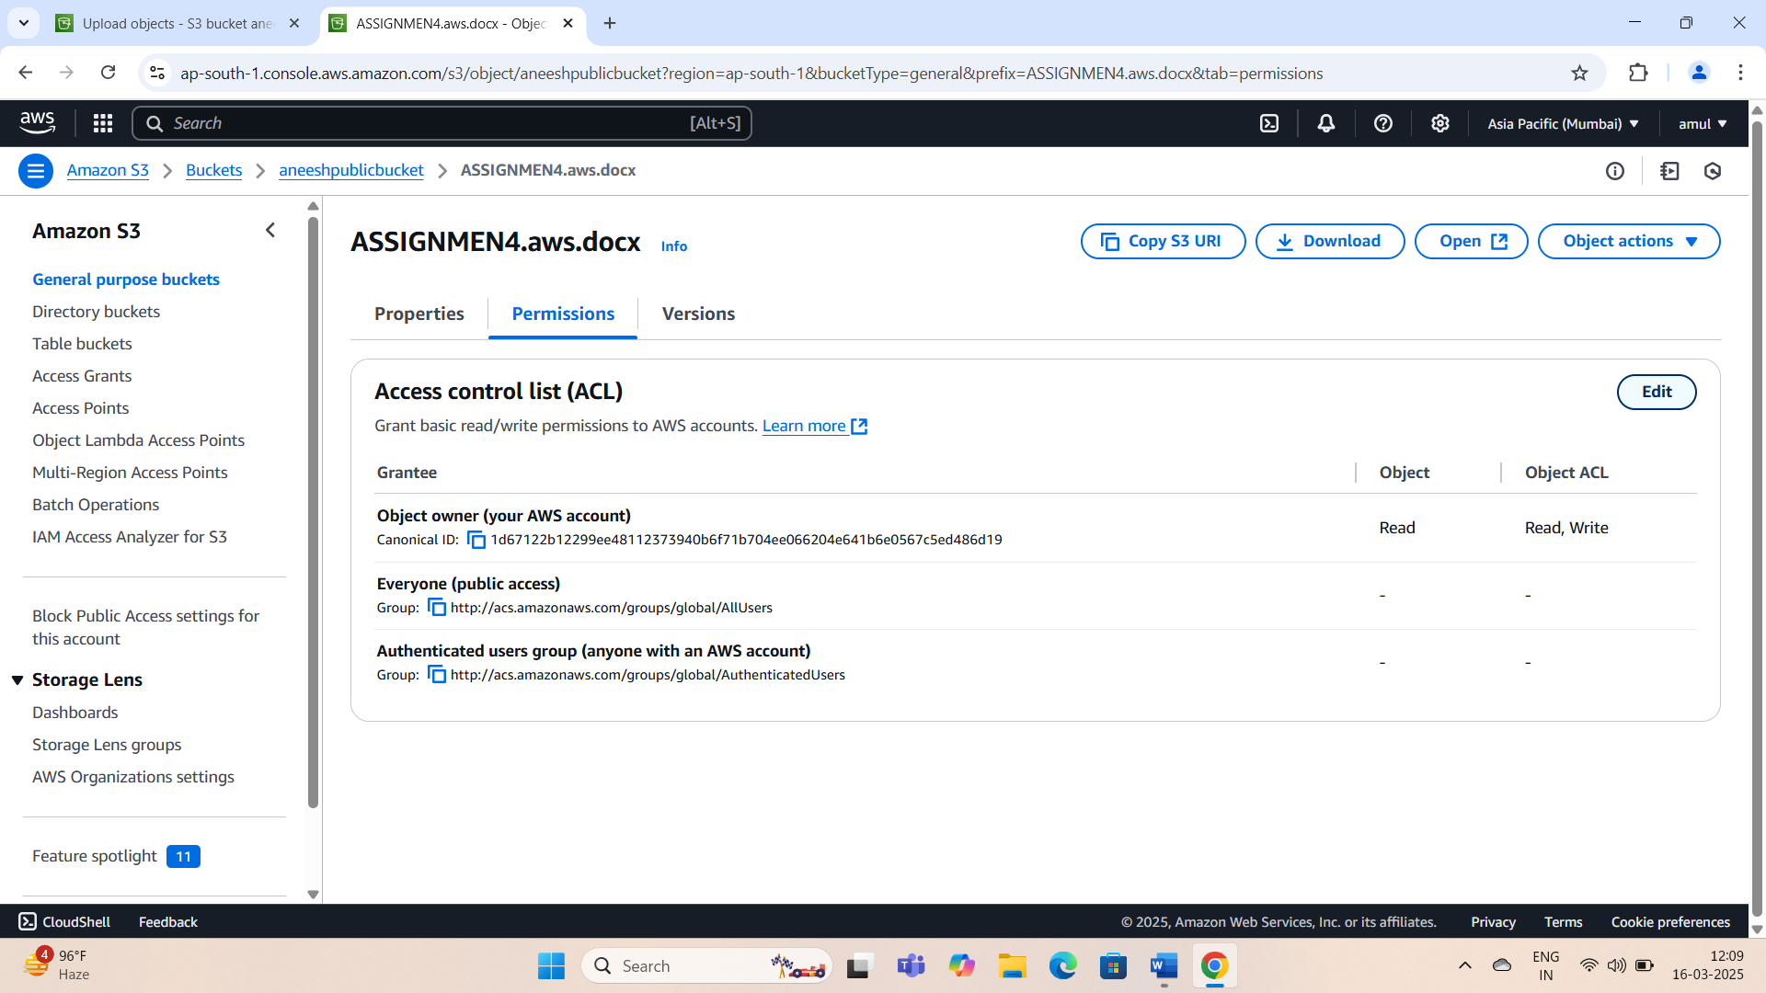

## 4.Grant Public Access:

## .Check the Read permission boxes for Object and Object’s ACL under Everyone(public access).

## .Tick the acknowledgment box confirming you understand the changes.

## .Click Save changes.

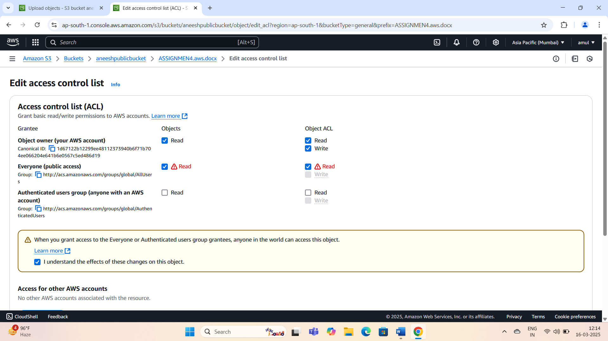

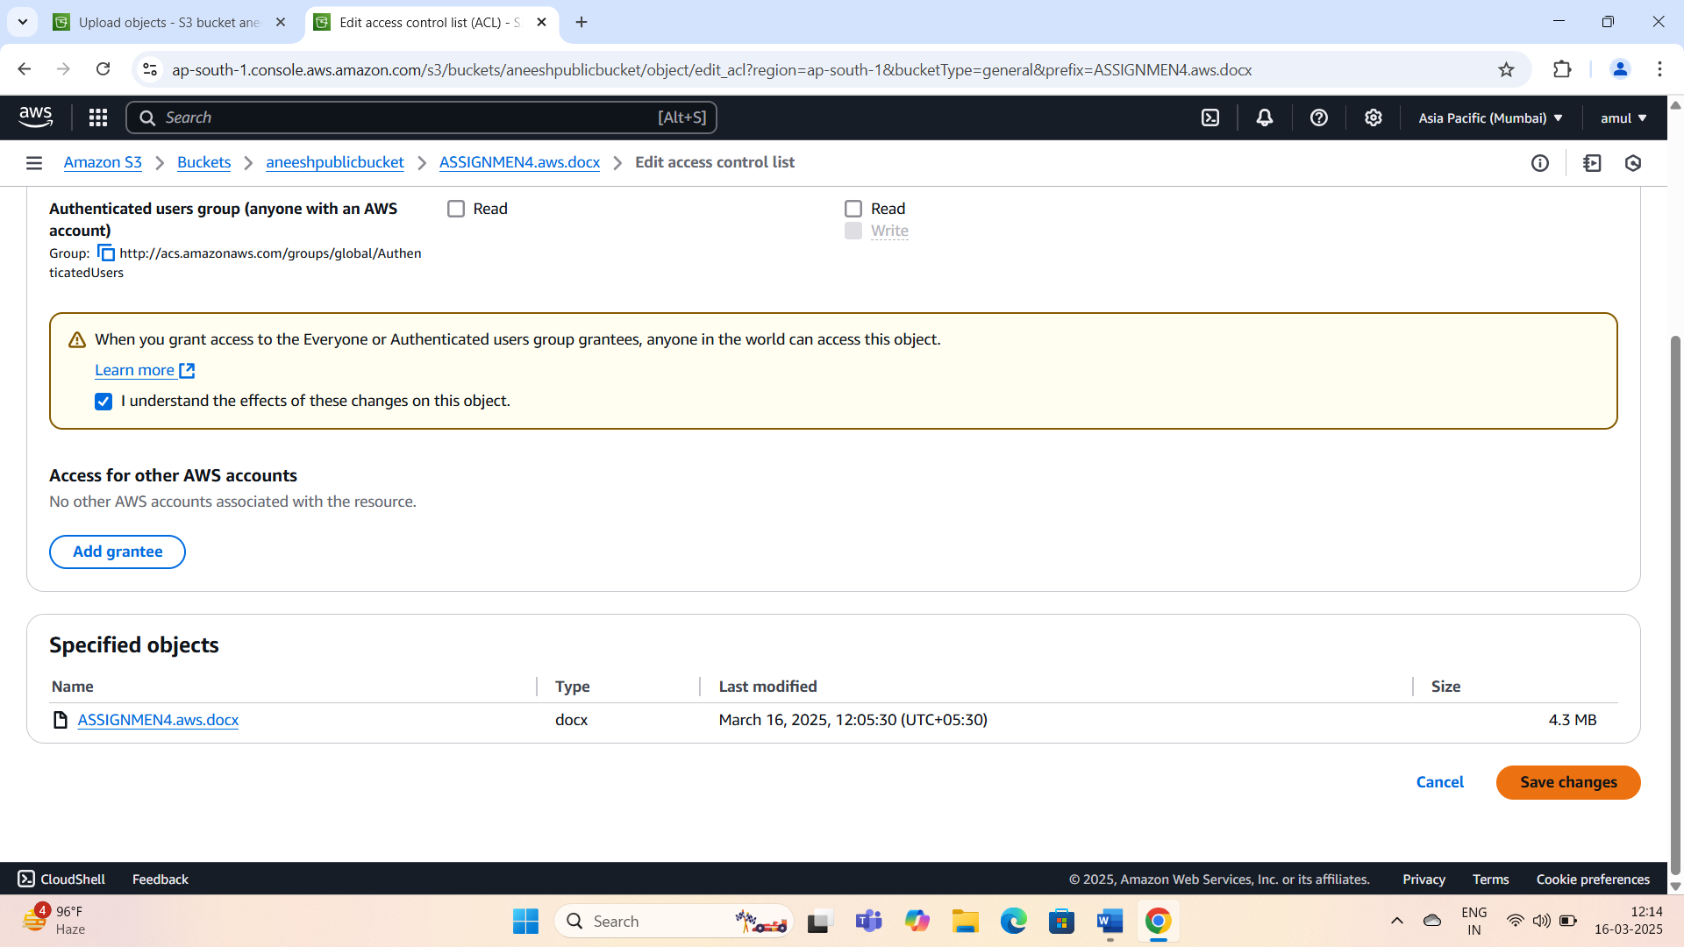

## 5.Verify Public Access :

## .Go to the Properties tab of the uploaded file.

## .Copy the Object URL.

## .Paste the URL into a web browser.

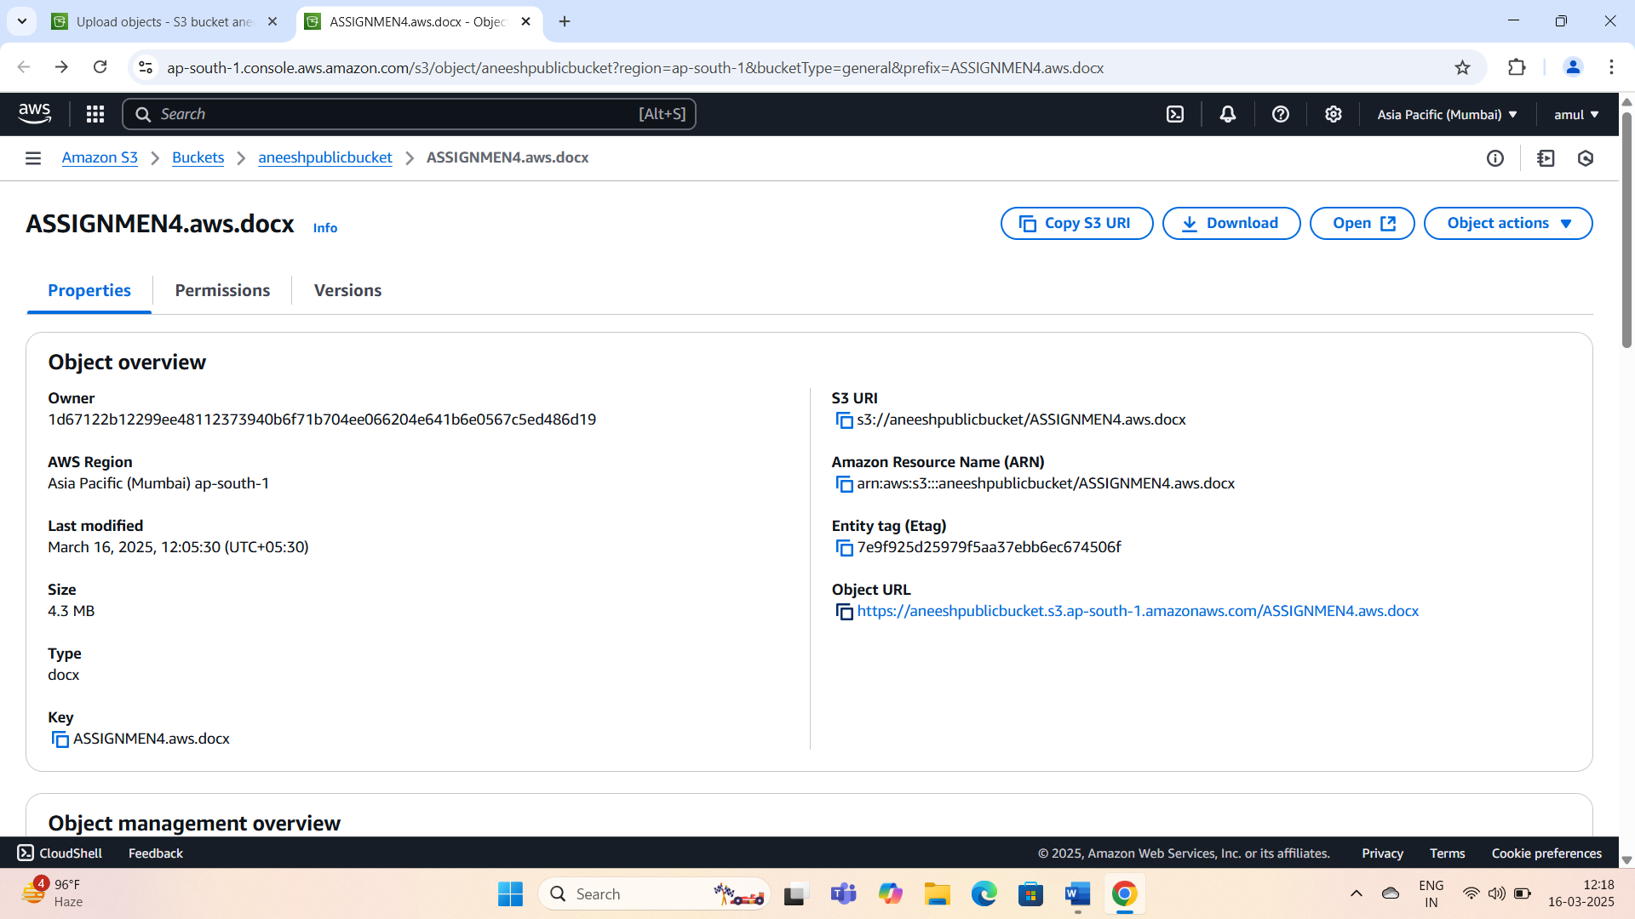

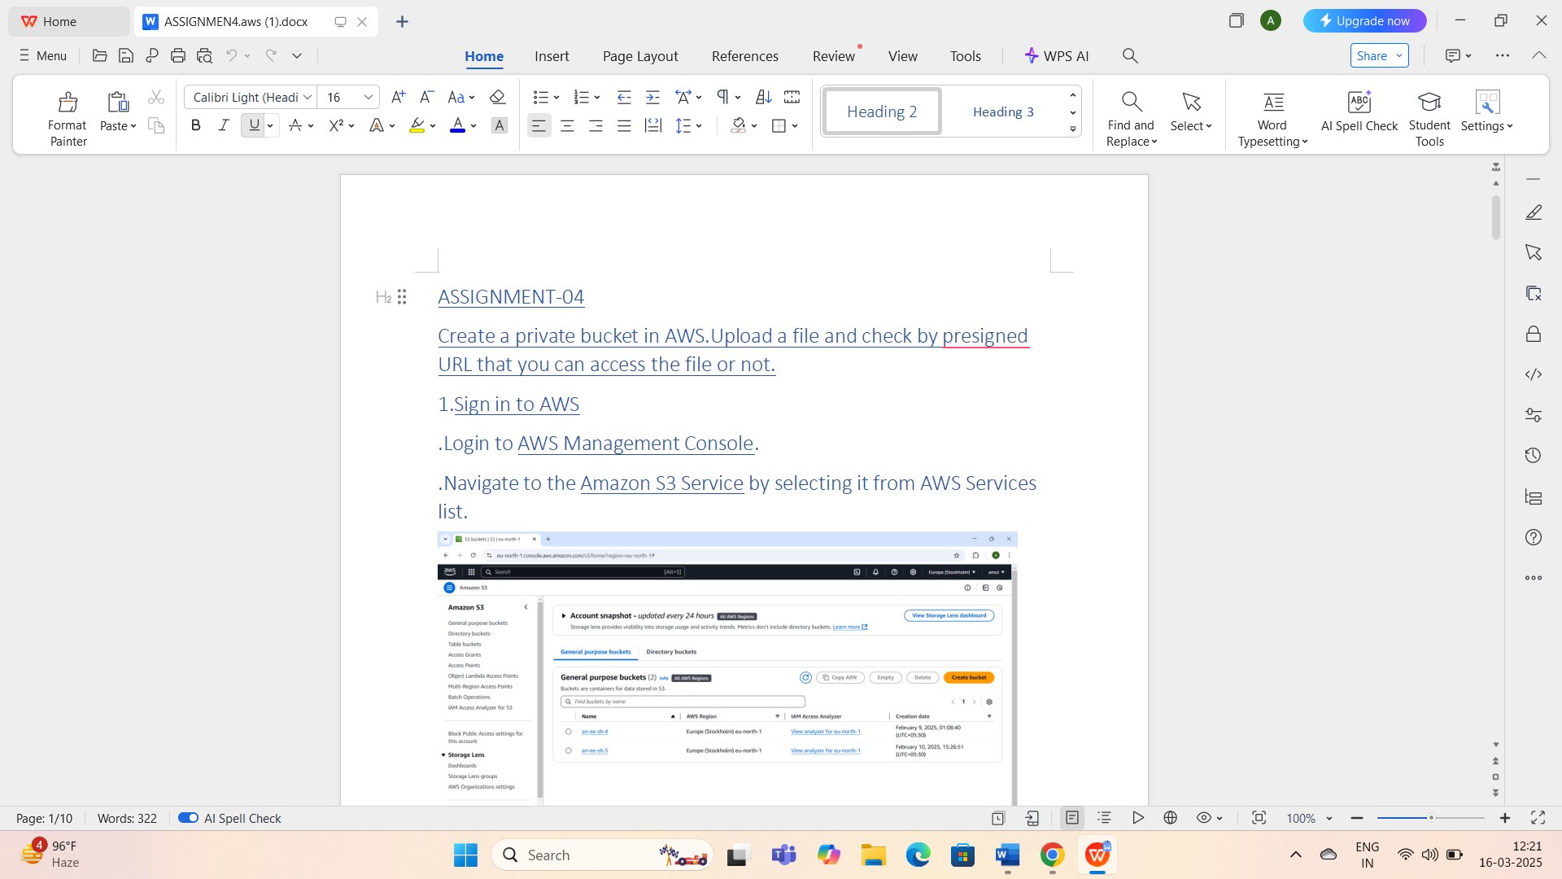

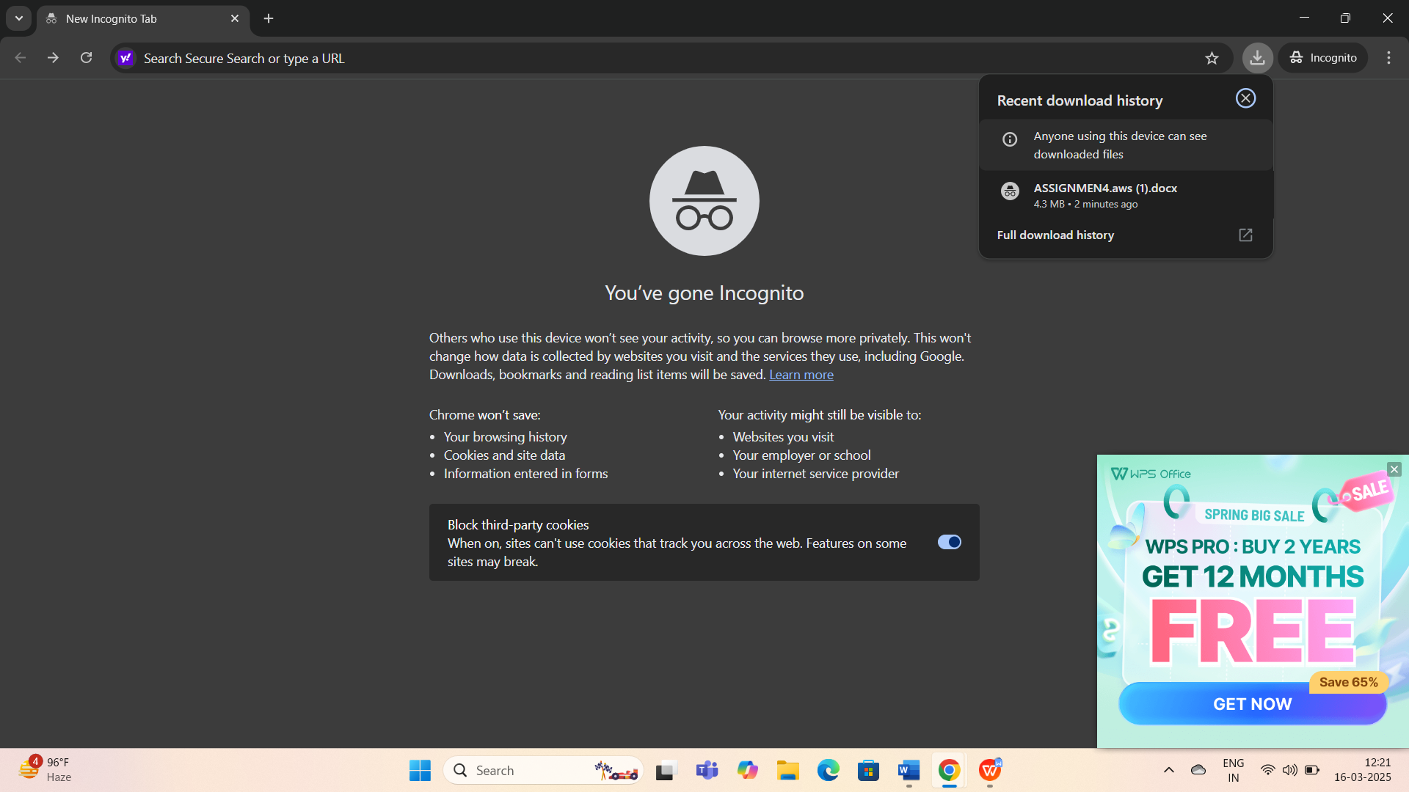

## If permissions are correctly set,the file should be accessed publicly.